* **Def.**
* **Individuals** are objects ___________________ a set of data.
* A **categorical/qualitative** **variable** take on category names or group labels
* 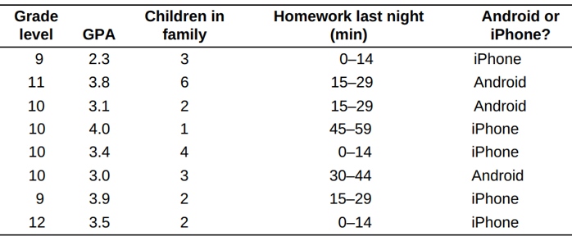A **quantitative/numerical variable** takes on _____________ values
* **How to distinguish categorical variable and quantitative variable?**
* **Def.**
* **Discrete variable:** the possible values of the variable correspond to _________ points
* **Continuous variable:** the possible values form an ____________ on the number line.
* **Def.**
* **A frequency table** shows the ____________ of individuals having each value.
* **A relative frequency table** shows the ___________________ of individuals having each value.

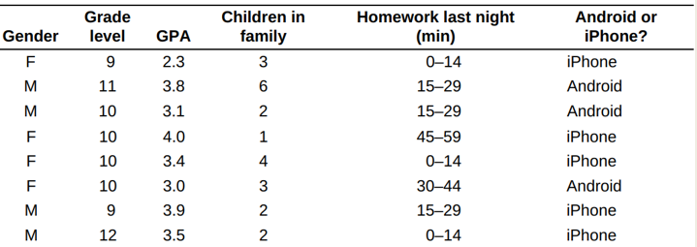

* **bar graph, pie chart**
* **Bar graph**
* bars equally wide
* Spaced intervals
* Name of the horizontal and vertical axis
* 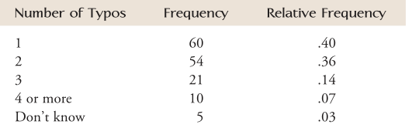Typos on a résumé do not make a very good impression when applying for a job. 150 senior executives were asked how many typos in a résumé would make them not consider a job candidate. The resulting data are summarized in the frequency distribution table below. Draw a bar graph to describe this data set.
* **Pie chart**
* A pie chart must include all categories that make up a whole, which might mean adding an “other” category, as in the left sample.
* **Draw a pie chart to describe the data set.**



* **Display and compare two categorical variables?**

A two-way table describes two categorical variables, organizing counts according to a row variable and a column variable.

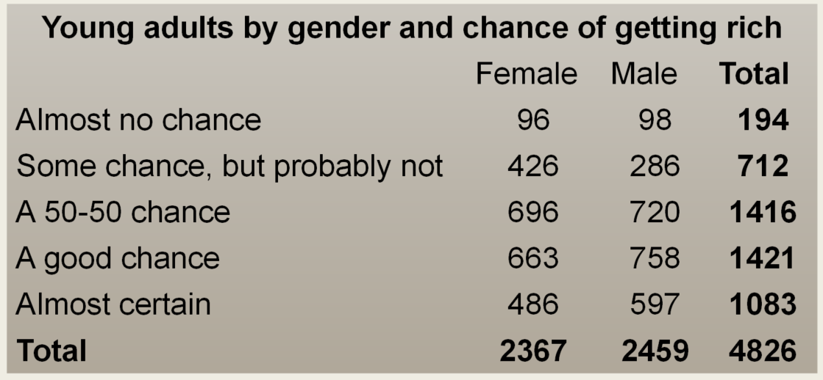

* **Find the frequency table of gender.**
* **The marginal distribution of one of the categorical variables in a two-way table of counts** is the distribution of values of that variable among all individuals described by the table.
* **What percent of people “almost certain”, given they are female?**
* **What is the distribution of chance of getting rich given they are female?**
* **Displaying Quantitative Data with Graphs**
* **Dotplot**

How good was the 2012 U.S. women’s soccer team? With players like Abby Wambach, Megan Rapinoe and Hope Solo, the team put on an impressive showing en route to winning the gold medal at the 2012 Olympics in London. Here are data on the number of goals scored by the team in the 12 months prior to the 2012 Olympics.  
1 3 1 14 13 4 3 4 2 5 2 0 4 1 3 4 3 4 2 4 3 1 2 4 2

* **How to Describe the Distribution of a Quantitative Variable**
* **S**
* **O**
* **C**
* **S**
* **Stemplot**

These data represent the responses of 20 female students to the question, “How many pairs of shoes do you have?” Construct a stemplot for the data.

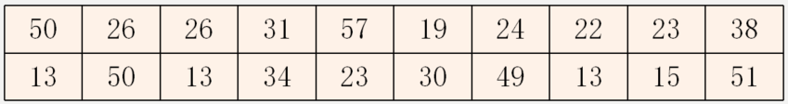

* + **Splitting stemplot**
  + **back-to-back stemplot**

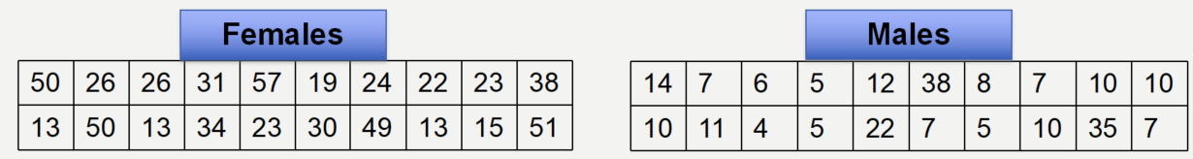

* **Histogram**

Sales tax rates vary widely across the United States. Four states charge no state or local sales tax: Delaware, Montana, New Hampshire, and Oregon. The table shows data on the average total tax rate for each of the remaining 46 states and the District of Columbia.

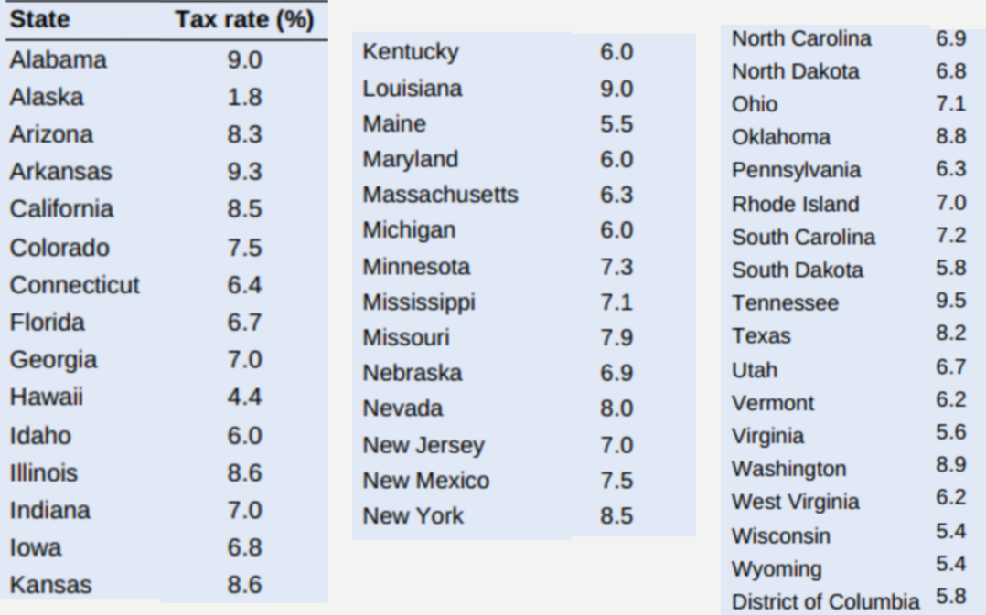

* **Cumulative Frequency**

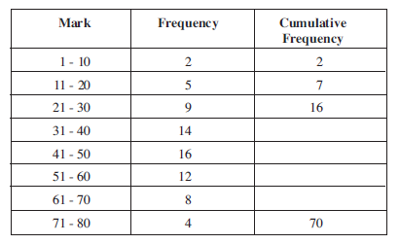

* **Practice**

